
G-Tak- Documentation

Introduction

- Created on: March 2021
- Developed by:Sadi Ashlaq
- Support via Email:sadi.ashlaq@gmail.com

This website is built with Laravel 7.7.1. I have also added few reusable components which speedup the development.

Project Information

This idea came up to me because I'm an expert in mobile software and hardware, most people have difficult time in getting the necessary help to fix their phones, my service will be their number one to go.

Main Goal
Lessen the time and effort for the client and come up with a trendy way to fix your phone.

General Description
- The website is made to help customers book appointment to fix their mobile, we will come to their doorstep after that
- The user need to fill a form with the problem they are facing, they must be logged in
- The user will be asked for a location so we can get to them
- The user will get a bill after the phone is fixed
- The website will have 3 types of users, Admin and super admin also normal user
- Normal user will be able to register/login then use our service
- Super admin will be able to control everything on the website and have access to every data
- Admin will be able to control everything on the website and have access to every data.

Frontend / Backend technologies

Backend
- PHP|Laravel Framework
- MySQL

Frontend
- HTML5
- CSS3
- JavaScript
- Bootstrap

Database Diagram

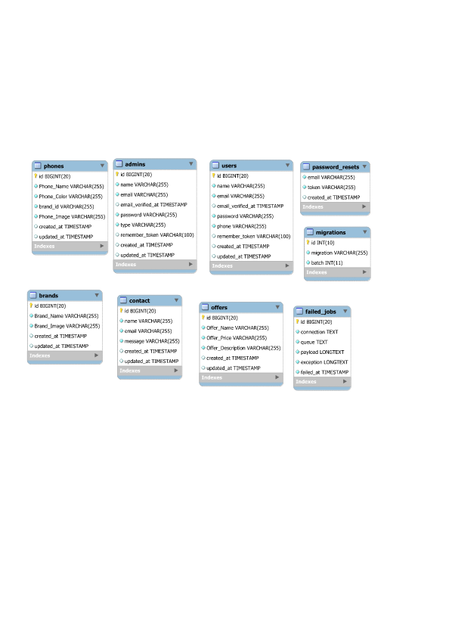

Installation

Given below are the steps you need to follow, to install the Project on your system:

Step 1:Open the terminal in your root directory(project directory) & to install the composer packages run the following command:

composer install
Step 2:By running the following command, you will be able to get all the dependencies in your node_modules folder:

npm install

Step 3:To serve the application you need to run the following command in the project directory. (This will give you an address with port number 8000.) Now navigate to the given address you will see your application is running.

php artisan serve

To change the port address, run the following command:
php artisan serve --port=8080 // For port 8080

Requirements
- PHP>= 7.2.5
- MYSQL

Laravel Structure
Project Directory
|--app
| --console
| --Exceptions
| --Http
| --Providers
| --Rules
|--bootstrap
| --Cache
|--config
|--database
|--node_modules
|--public
| --CSS
| --fonts
| --img
| --js
|--resources
| --views
| --auth
| --dashboard
| --layout
| --partials
| --admin_footer.blade.php
| --admin_header.blade.php
| --layouts
| --public
|--routes
| --api.php
| --channels.php
| --console.php
| --web.php
|--storage
|--tests
|--vendor
|--editorconfig
|--env
|--env.example
|--styleci.yml
|--artisan
|--composer.json
|--composer.lock
|--package.json
|--package-lock.json
|--phpunit
|--README.md
|--webpack.mix

Obstacles
In the beginning it was hard due to the lack of knowledge in the framework I was working on, I had to google a lot of things at first to figure out how to do things and so on, but eventually things have become more easy and my vision was clearer and made me become more productive in my graduation project.

Security
My website has been through some security checks, making sure that the guards are working properly and each page matches the credentials it needs from users.

Credits
I used the following resources as listed. These are some awesome creation and I am thankful to the community.

Plugin | Link
Bootstrap | http://getbootstrap.com/
jquery | https://jquery.com/
Data Table | https://datatables.net/
FontAwesome | https://fontawesome.com/

Mockup
